From: <https://marisol-nostromo.medium.com/what-are-the-neocons-revisited-c4536571782f>

Date: Mar 18, 2022 - A 9 min read.

What Are the Neocons, Revisited

This article is intended to be the sequel to [*What Are the Neocons, Really?*](https://marisol-nostromo.medium.com/what-are-the-neocons-really-19247b03a436)

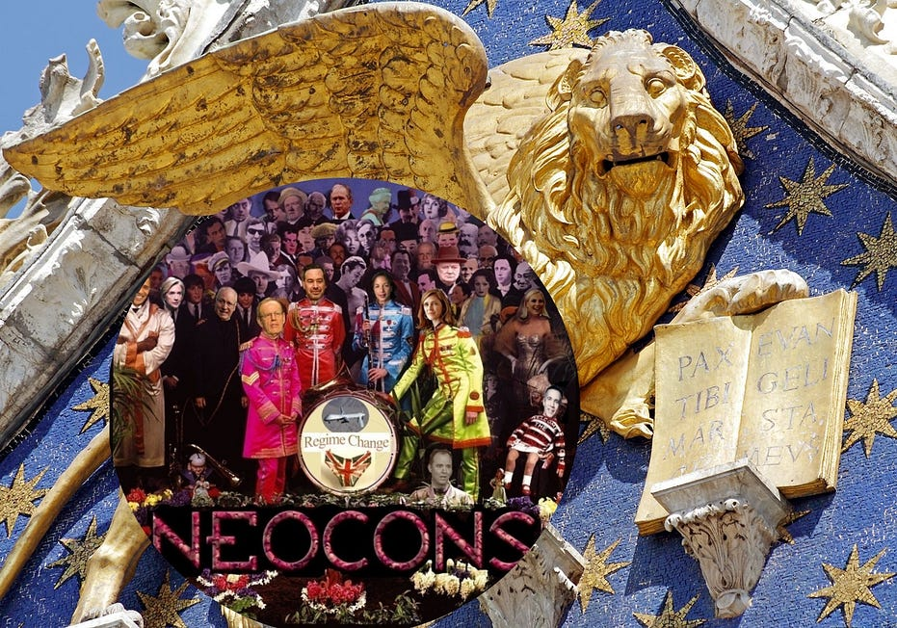

Throughout American history there has been a constant tug-of-war between

1. the anti-imperial, or shall we say, “American” faction, and
2. the Anglophile faction.

Unfortunately, with the advent of the Cold War and the modern, re-branded version of the [British Empire](https://marisol-nostromo.medium.com/what-became-of-the-british-empire-3d2b4c1ffd5a),

1. the Anglophiles became hegemonic, and
2. beginning in the 1960s, people began to refer to them as “neoconservatives.”

There have been many attempts lately to concoct new revisionist histories of the United States. It has become especially trendy to disparage the American Revolution and ascribe to its leaders all manner of venal and corrupt motives. But there was a core grouping of intellectuals who were indisputably anti-imperialist and specifically, anti-British, among them Alexander Hamilton and John Quincy Adams.

Unfortunately, there were other political factions at that time, including some that had no desire to break from the British, or their methods. As writers such as [Lyndon LaRouche](https://marisol-nostromo.medium.com/r-i-p-lyndon-larouche-7cf47083b7f0) and [Anton Chaitkin](https://www.antonchaitkin.com/about) have persuasively argued, there has been an unbroken continuity of this pro-imperial faction up to the present day, and it has emerged from time to time in various forms, including the Confederate States of America and the predators of Wall Street. [Or as Michael Hudson would have it, 'Financial Capitalism.] -FNC]

Following the death of FDR, **the Anglophiles gained enough influence to involve the U.S. in a continual series of illegal, undeclared wars against former colonial nations.**

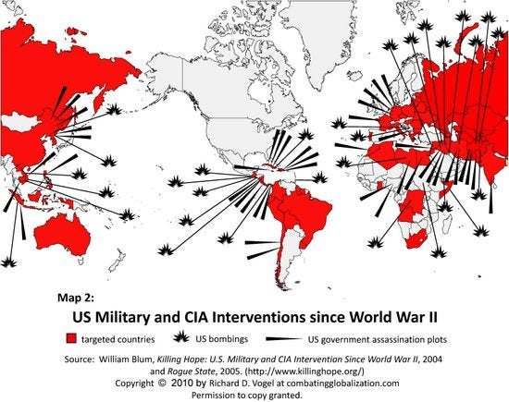

However, many Americans had qualms about these wars, about their legitimacy, and also about the very substantial price tag. And although the neocons were on very friendly terms with the arms manufacturers, their interest in these wars was not strictly pecuniary. They aspired to something more. They wanted **an Empire upon which the Sun Never Set**, and with the demise of the Warsaw Pact in 1991, they were convinced that the goal was within their grasp: a “**unipolar world**.” However, to achieve that, they would need the right sort of motivation for the American citizenry to permanently abandon any vestige of the ideals of the American Revolution.

**A major stumbling block was the UN Charter**, which prohibits the threat or use of force and calls on all Members to respect the sovereignty, territorial integrity and political independence of other States. This hearkens back to the 1648 Treaty of Westphalia, which ended the Thirty Years War and established **the principle of “**[**Westphalian Sovereignty**](https://www.newworldencyclopedia.org/entry/Peace_of_Westphalia)**,”** a source of much vexation to the neocons. Fortunately for them, the Mother Country came to the rescue in the form of British Prime Minister Tony Blair’s visit to Chicago in 1999, where he announced the “[Blair Doctrine](https://archive.globalpolicy.org/empire/humanint/1999/0422blair.htm)”: simply claim that your target nation is violating the human rights of its citizens, and you are free to intervene to your heart’s content.

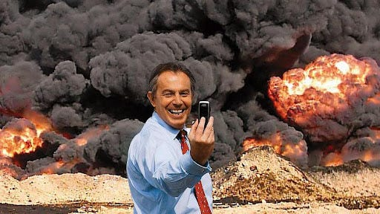

Tony Blair

However, it was the events of September 11, 2001 which brought joy to the hearts of neocons everywhere. The **neocons** rushed to exploit the post-9/11 trauma and anxiety, and managed to sell the American population a number of truly ghastly measures, including the Patriot Act, which enabled

1. a massive expansion of intrusive surveillance of the population, as well as
2. indefinite detention without trial of immigrants and
3. other draconian policies that purported to defend Freedom.

**However, the great achievement of the neocons during this period was** the successful marketing of a whole series of wars against Middle Eastern nations which had nothing whatsoever to do with the September 11 attacks. Ironically, al-Qaeda, the group generally considered to be the author of those attacks, was an offshoot of the Mujaheddin, which during the 1980s was sponsored by the neocons as a proxy force to harass the Soviets in Afghanistan. But the American public, in a state of collective PTSD, did not demand either logic or evidence when the neocons and their pet media offered an opportunity to lash out at nations on the other side of the globe.

Many commentators with a populist inclination have suggested that these wars were “oil wars.” Of course, as Donald Trump demonstrated in Syria, the U.S. is not above pilfering the resources of the nations they invade, but the neocons, as we mentioned earlier, are not motivated by something as petty as monetary gain. They want global domination, and the principal game plan, since the 1970s, has been something called the Bernard Lewis Plan.

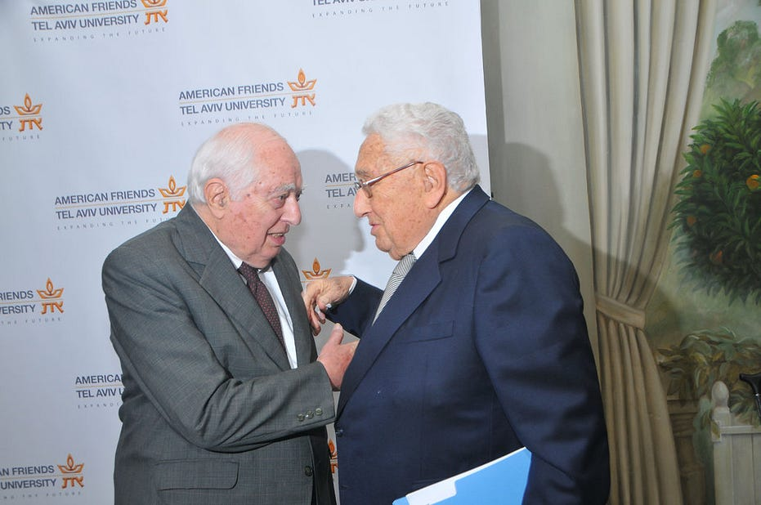

Bernard Lewis and Henry Kissinger

Professor **Bernard Lewis was a leading British intelligence operative who arrived on our shores in 1974 to take up joint positions at Princeton University and the Institute for Advanced Studies.** He began to promote the idea that the spread of Islamic fundamentalism could create a zone of instability (later called the [Arc of Crisis](https://www.foreignaffairs.com/articles/russian-federation/1979-03-01/arc-crisis-its-central-sector)by neocon think-tankers) along the southern flanks of Russia and China (this was a further elaboration of what 19th century Empire strategists called the “Great Game”.) This was considered a good thing, since a cherished goal of British geopolitics is the sabotage of potential competitors.

The use of Islamic radicals as mercenaries was pioneered by the British in the 1950s, who attempted to use the Muslim Brotherhood against Egypt’s nationalist president, Gamal Abdel Nasser. Under Lewis’ tutalege, the U.S. funded, trained and armed the Mujahideen in Afghanistan. They soon morphed into groups such as al-Qaeda and ISIS and began to commit acts of terrorism in Iraq, Yemen, Libya, Syria, and other countries, becoming a “Frankenstein’s monster” of sorts.

But **the neocons, undeterred, began to experiment with using other types of violence-prone radical groupings, leading to the 2014 coup in Ukraine.** This coup was organized by a group of U.S. officials led by Assistant Secretary of State for European and Eurasian Affairs Victoria Nuland, whose husband is leading neocon Robert Kagan, a founder of the Project for a New American Century (PNAC). **Nuland utilized the remnants of the WWII-era Organization of Ukrainian Nationalists-Bandera (OUN-B)**, a pro-Nazi grouping which joined forces with Germany against Russia, and killed 70,000 Jews and Poles in Ukraine during 1943 alone. Their heirs, such as **Svoboda** and **Right Sector**, played a key role in the violent protests on the Maidan plaza in Kyiv which lead to the coup, and were subsequently integrated into both the government and the Ukrainian military, where they were instrumental in attacking the eastern republics of the Donbass.

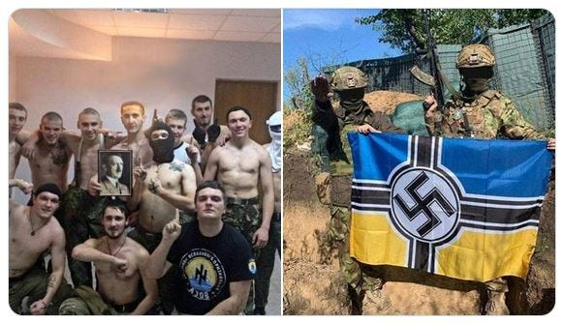

Members of the Azov Battalion in Ukraine, now formally a part of the Ukrainian army

The population of the Donbass region is primarily Russian-speaking. When the coup regime, made up of individuals hand-picked by Victoria Nuland, took power, it began repressive measures against Russian-speaking Ukrainians, reviving the tradition of OUN-B. Use of the Russian Language was outlawed. In response, the Donbass declared its independence and formed the Donetsk and Luhansk “People’s Republics”, at which point they came under violent attack by neo-Nazi militias as well as the official Ukrainian armed forces. For eight years, Russia protested these attacks, which killed 14,000 in the Donbass. **They also objected strenuously to the steady eastward expansion of NATO**, which violated [explicit promises](https://scheerpost.com/2022/02/24/not-one-inch-eastward-how-the-war-in-ukraine-could-have-been-prevented-decades-ago/) made by NATO leaders in 1990.

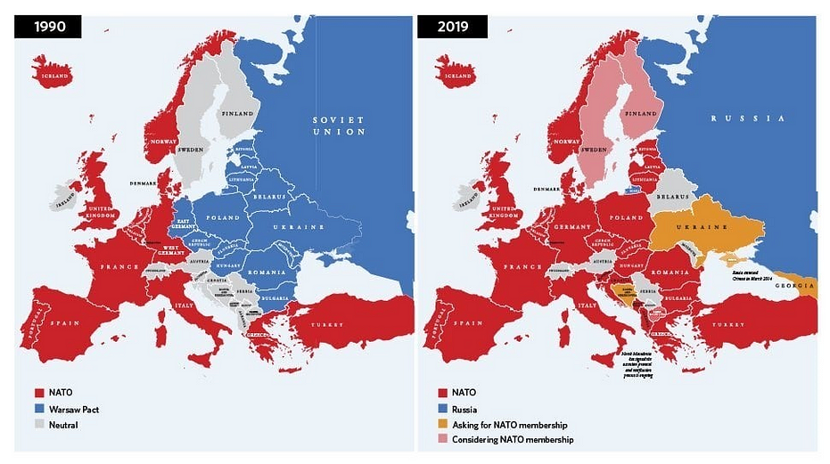

**Russia warned, year after year, that these encroachments on its borders could not be tolerated.** Russia also warned that it could not tolerate the attacks on the Donbass. The Minsk II agreement, signed in 2015, provided for a ceasefire, legalized the speaking of Russian in the Donbass, and gave the Donbass a degree of autonomy. However, the newly installed Ukrainian government refused to implement the agreement that it had signed.

Meanwhile, in the U.S., the neocons had concocted an astonishing theory that Russia had [somehow manipulated the 2016 presidential election](https://marisol-nostromo.medium.com/americas-color-revolution-343cdf1b1181) to install Donald Trump, who was alleged to be some sort of Russian agent. This “[Russiagate](https://consortiumnews.com/2020/05/19/ray-mcgovern-turn-out-the-lights-russiagate-is-over/)” conspiracy was far more fantastical than any of the anti-Russian conspiracy theories promoted by the John Birch Society back in the 1960s, but despite a complete lack of any evidence, it was embraced by the corporate media. Constant repetitions of these allegations created an impression in the minds of many grassroots Americans that there must be some basis in fact, and **set the stage** for what was to come next.

After eight years of diplomatic protests and warnings, Russia had

1. begun to amass military forces along the border with Ukraine, and
2. demanded from the Anglophile West a formal treaty with security guarantees.

The U.S. and U.K. refused to respond. In February of 2022, Russia invaded, with the stated goals of the demilitarization and “de-Nazification” of Ukraine.

This was another thrilling moment for the neocons, because it provided an excuse for them to do things they had long yearned to do. They unleashed an unprecedented torrent of war propaganda through the electronic media which they controlled, primed by six years of Russiagate. Vladimir Putin was demonized, while U.S. President Joe Biden and Ukrainian President Volodymyr Zelenskyy were cast as heroic figures. A few lone voices of dissent, such as FOX News commentator Tucker Carlson and former Democratic presidential candidate Tulsi Gabbard, were vilified as traitors.

In what was clearly a closely-coordinated, focus-grouped strategy to market the war, every neocon functionary from Tony Blinken to Victorian Nuland to Boris Johnson used the term “unprovoked” to describe the invasion, over and over, in all of their daily tweets and social media posts, **to describe an action by Russia which they had spent eight solid years provoking**.

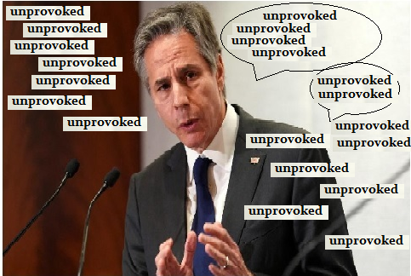

More importantly, the [neocon-allied “tech” monopolies](https://greenwald.substack.com/p/the-threat-of-authoritarianism-in?s=r) took this opportunity to flex their muscles, imposing unprecedented levels of censorship on the information available to the world. YouTube blocked access, *globally*, to Russian news services

1. RT,
2. Ruptly, and
3. Sputnik.

Countless independent journalists were banned from social media organs for posting inconvenient information, such as photos of Nazi rallies in Ukraine.

Finally, the U.K., with the U.S. and others in tow, launched [unprecedented](https://twitter.com/RepThomasMassie/status/1504562598615863303) financial warfare against Russia. French Finance Minister Bruno Le Maire said the quiet part out loud when he told France Info radio, “We’re waging an all-out economic and financial war on Russia. We will cause the collapse of the Russian economy.” It is important to understand that *this has been the chief objective of the neocons all along*, and they were simply waiting for a suitable pretext. (Joe Biden, supposedly having one of his characteristic “senior moments,” said in a public meeting that Putin “cannot remain in power,” then later insisted that he had not called for regime change in Russia.)

A suitable pretext would be one that enables them to argue to panic-stricken populations in the Anglophile bloc that the ensuing chaos and misery in the world economy was somehow Russia’s fault, and not the inevitable consequence of the insane orgy of financial speculation that Anglophile financiers have enjoyed since Nixon shut down the Bretton Woods exchange system in 1971. Insiders in the neocon camp know that the financial system is rotted out and ready to fail. They are extremely concerned that this will enable the emergence of a new alliance, with China and Russia as the nucleus, that is oriented toward developing the physical economy, with an emphasis on science and infrastructure. The backbone of this new alliance is the [Belt and Road Initiative,](https://www.beltroad-initiative.com/belt-and-road/) which the British House of Lords [warned](https://publications.parliament.uk/pa/ld201719/ldselect/ldintrel/250/250.pdf) in 2018, “poses a threat to the current international governance system.”

China remains a great source of anxiety for the neocons. **Its economy is strong enough to bolster and defend Russia against the financial onslaught of the Anglophiles**, and a few weeks before Russian troops entered Ukraine, Putin and Xi held an important meeting during the Beijing Olympics in which contingency plans were undoubtably discussed. Neocon pundits have attempted to craft a line of propaganda, aimed at the leadership of China, that Russia is a liability to them. However, the Chinese have learned from their experience with Kissinger’s “China Card,” and they are unlikely to fall for it twice. Thus, the neocons have also attempted to foster insurrections in Xinjiang, Hong Kong, and Taiwan, based on the same model as the Ukraine conflict: provocations that escalate until China can no longer tolerate them, and must move militarily.

Under the circumstances, the neocons are left with very limited options, among them nuclear brinksmanship, which they are now attempting to argue is not as dangerous as everyone used to think. But it is.

What can you do to oppose the neocon joy-ride to Armageddon? Here are three petitions that will get you started:

* [President Biden: Fire Victoria Nuland](https://www.change.org/p/mr-president-fire-victoria-nuland)
* [Convoke an International Conference to Establish A New Security and Development Architecture for All Nations](https://schillerinstitute.nationbuilder.com/convoke_an_international_conference_to_establish_a_new_security_and_development_architecture_for_all_nations)
* [Negotiate for peace in Ukraine!](https://www.codepink.org/ukrainetalks)

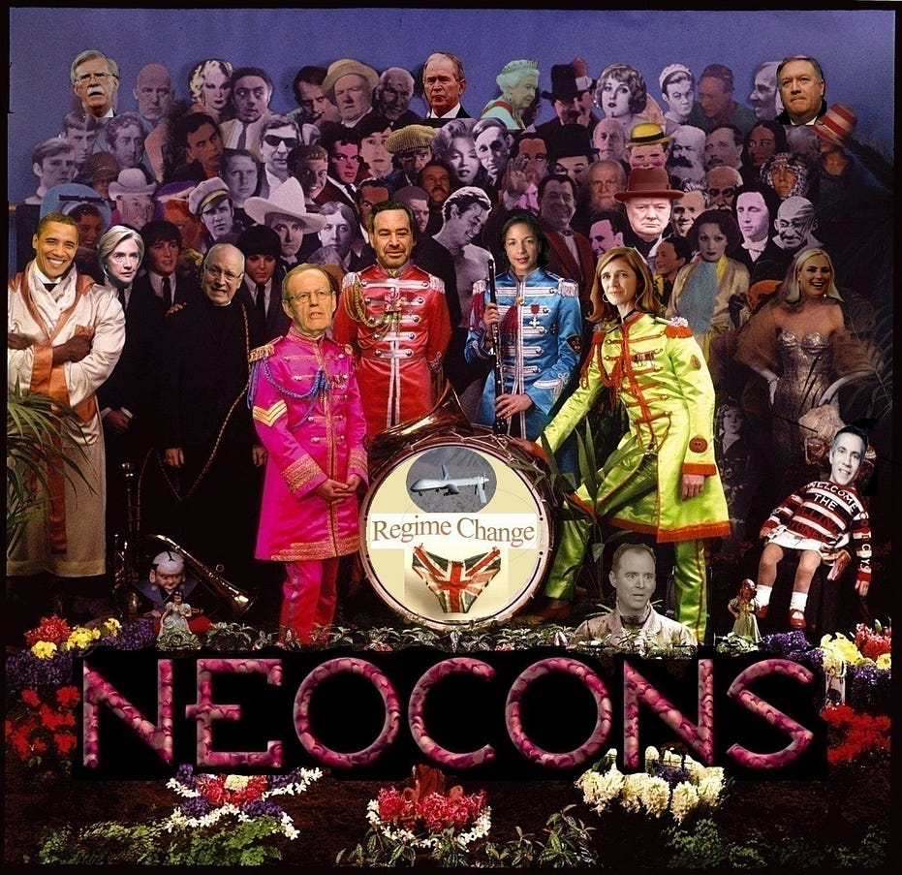

[Neoconservatives](https://medium.com/tag/neoconservatives?source=post_page-----c4536571782f---------------neoconservatives-----------------)

[Neoconservatism](https://medium.com/tag/neoconservatism?source=post_page-----c4536571782f---------------neoconservatism-----------------)

[Ukraine](https://medium.com/tag/ukraine?source=post_page-----c4536571782f---------------ukraine-----------------)

[Russia](https://medium.com/tag/russia?source=post_page-----c4536571782f---------------russia-----------------)

[Putin](https://medium.com/tag/putin?source=post_page-----c4536571782f---------------putin-----------------)